**Vaping & Legislation**

Group Members: Brad Barrett, Manny Ramos, Samantha Devlin, Tim Tallent

Motivation: Recent political conversations with the rise of E-Cigarettes.

“How has legislation on E-cigarettes changed smoking habits?”

**Hypothesis**

(HA) Hypothesis: The adoption of Anti-E-cigarette legislation by states has a direct impact to reducing the percentage of adult E-cigarette users.

(Ho:) Null: The adoption of Anti-E-cigarette legislation by states does not have a direct impact on reducing the percentage of adult E-cigarette users.

“What states have the most legislation, how did that effect smoking habits?”

“Which legislation was most effective?”

“How did legislation effect smoking habits by demographics?”

**Data Sources:**

* CDC STATE System E-Cigarette Legislation - Tax U.S. Department of Health & Human Services — 1995-2020
* Centers for Disease Control and Prevention (CDC)
* State Tobacco Activities Tracking and Evaluation (STATE) System
* E-Cigarette Legislation—Tax

**Behavioral Risk Factor Data:**

* Tobacco Use (2011 to present) Survey Data 2011-2018
* Centers for Disease Control and Prevention (CDC)
* State Tobacco Activities Tracking and Evaluation (STATE) System
* BRFSS Survey Data

**Data Analysis**

* Planned Analysis: We are going to compare the adult usage rate of the population data to sample data of states with high levels of Anti-E-cigarette legislation to determine statistical significance.
* Secondary Analysis: If correlation is determined between high legislation states, then we will determine which forms of legislation are more effective.

**Amount of Legislation vs. Usage**  
Highest Count of Legislation (CA, DC, KS)

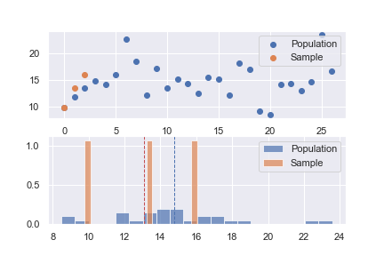

T-test Statistic (-0.904) P-Value 0.46

**Single Stamp Tax vs. Usage**

Highest Stamp Price (KY, PR, UT)

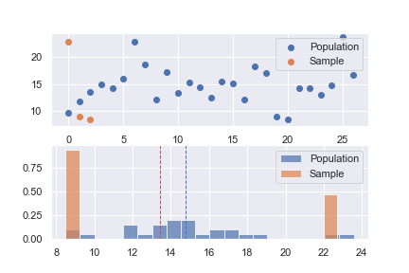

T-test Statistic (-0.286) P-Value 0.80

**Highest % Tax to E-Cig Unit Price**

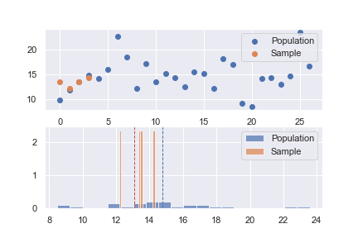

* States observed and Tax % Value
  + VT 92.0%
  + MA 75.0%
  + DC 72.0%
  + MN 65.0%
* Sample Average % Adult use 13.1%
* Population Average % Adult use 14.8%
* Statistic (-3.187)
* P-Value – 0.049
* Sufficient evidence to reject null hypothesis that % Tax legislation is not impacting Adult use of E-Cig.

**Discussion / Observations**

States with the most legislation has the “_____” amount of e-cigarette smokers.

How has legislation on E-cigarettes changed smoking habits?”

“What states have the most legislation, how did that effect smoking habits?”

“Which legislation was most effective?”

“How did legislation effect smoking habits by demographics?”

* States with the highest legislation did not produce a P-value to reject the null hypothesis
* Most effective legislation was % to total cost tax P-value <0.5
* There has been a downward trend of cigarette and E-Cigarette use in states with the most legislation, except for American Indians in California, which have a spike in usage.

**Post Mortem**

* The biggest difficulties we had was narrowing down a topic to discuss. We began with the idea of how vaping effected the cigarette industry, and the tobacco industry as a whole. We came to the conclusion to narrow down to the effects of legislation and take it further by breaking it down by race.
* If given more allotted time we would have further dove into the effects on age, gender, income, education, marketing tactics.

**Scatter Plot – Showing top states with highest legislation**

* Y-Axis represents the total number Provisions/Legislation
* X-Axis is the percentage of e-cigs users
* Colored key of all states (i.e locations)

**Pie Chart: Representing all States/locations with highest provisions**

**Nation Wide Use of Tobacco By Race**

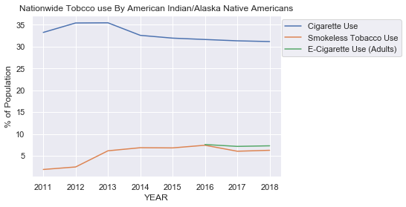 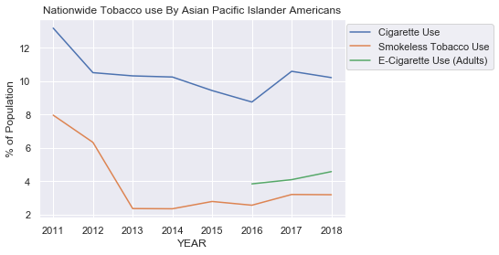 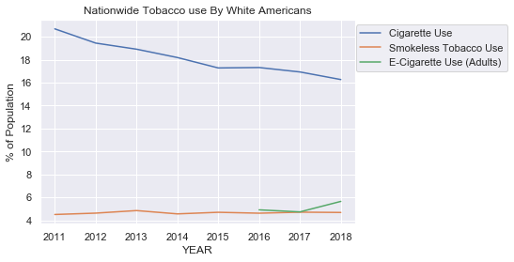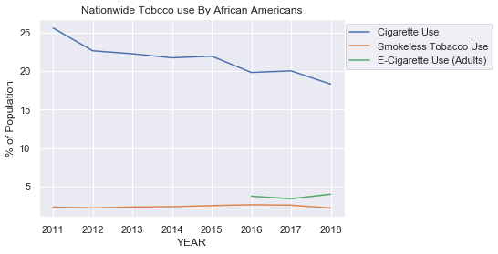 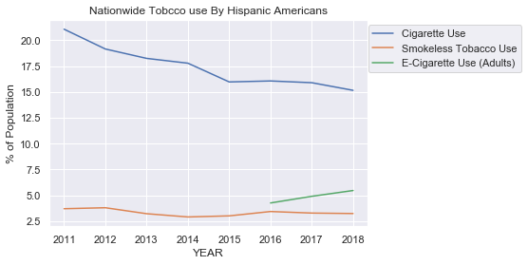 

* We broke the data of tobacco use nationwide by specific race and their individual smoking trends.
* Comparing the data, it appears all races have similar trends, and cigarette use is the most frequently used but on the downward path. While E-Cigarettes, while in lower numbers, are slightly on the rise since data was being recorded.
* It is observed American Indian and Alaskan Native Americans have the highest percentage of tobacco use across all methods; Cigarette, E-Cigarette, and Smokeless.